# **­­­****MWENGE CATHOLIC UNIVERSITY**

# **PROGRAM: BACHELOR OF SCIENCE IN COMPUTER SCIENCE**

# **NATURAL SCIENCE AND INFORMATION TECHNOLOGY DEPARTMENT**

# **FIELD PRACTICAL TRAINING REPORT CONDUCTED AT SKYNET SOLUTION COUNCIL**

**AUTHOR. : JEREMIA JASTINE KAWISHE**

**REGISTRATION NO. : T/DEG/2020/0088**

**SUPERVISOR. : BALTAZAR JOSEPH**

**SEMESTER. : SECOND**

**YEAR OF STUDY. : SECOND YEAR**

**ACADEMIC YEAR. : 2021/2022**

**SUBMISSION DATE. : 25/04/2022**

**DESCRIPTION**

I was conducted field practical training at **Skynet solution** from **07th march 2022** to **08th** **April 2022**, I conducted field practical training for almost about five weeks. I conducted different activity during my field practical training and I were acquiring different skills and knowledge due to the activities that i were assigned. I was assigned many activities most were graphics design, introduction to website development. Also there are some other activities I was assigned but in small scale like prepare the network cable and Ethernet wire, data recovery, instillation of the software such as operating system Microsoft office and ant virus to the computer, bypass password by using software called **spotmau**, update wireless card of office desktop and so on.

**PROBLEM IDENTIFICATION**

## Staying updated about Design Trends

## Finding Creative Fonts

## Unrealistic Timelines or Timely Payment:

## Inefficient Workflow and Communication

* **There's no clear path**
* **Overused stock images and icons**.
* Imbalanced Colors
* Unclear Images
* Unclear Objective
* Lowering the Design Standards
* Late Feedback Causes Disruption
* Not Responding to Questions & Poor Search
* Slow Website & Server Response Time
* Low-Quality Content & Grammar Issues

**DISCUSSION**

## Staying updated about Design Trends

## No matter how hard the designers try to stay on top of the prevalent trends, they always feel like something new they don’t know about. Also, [trends in design are changing very frequently](https://line25.com/articles/12-branding-trends-we-can-expect). Even in designing, different trends are going on for digital marketing, print, packaging, website, and other designing streams, which makes it harder for designers to be aware of all of them.

**Solution:**

* It is good to [bookmark some excellent design article websites](https://www.editorx.com/shaping-design/article/2021-web-design-trends-report) that cover various design-related trends. Another good approach that you should cultivate is taking some time out weekly to check out design-related websites such as Behance, Dribble, etc. Social media, especially Instagram, can also be an excellent source to gauge the latest market trends in digital design.

## Inefficient Workflow and Communication

## Seamless communication is the foundation of any good project, irrespective of the sector. However, for graphic designers, the lack of streamlined communication can prove to be very detrimental. The same goes for workflow. As a designer, you need to have clarity of how the project is going. With the rise in remote working, this problem has further aggravated.

**Solution:**

The best way to ensure seamless communication is to set up proper channels. There are good project management and communication tools available like Slack, Asana, Trello, and more that you can try out. You should also set up a review mechanism and adhere to it to ensure timely delivery of your designs.

## Finding Creative Fonts:

Designers always feel a constant shortage of good quality design resources, especially fonts for their designs. As a designer, either you are tired of using the same set of fonts, or the client forces you to create something more creative. Either way, you will always feel that you are poor in terms of font collection, and there exists a good font out there that you need to search and find.

**Solution:**

A good knowledge of typography is imperative for designers. You need to know which font will look good in which design and which other font it can be paired with. Based on that, you can search for strong fonts or [handwriting fonts](https://www.editorx.com/shaping-design/article/handwriting-fonts), or retro fonts. Also, as a designer, it will be a good practice to maintain a folder structure for your fonts which can come in handy for searching.

## Unrealistic Timelines or Timely Payment:

The most common two problems of graphic designers we have kept in last as these are something that cannot be solved quickly. Time and again, you will come across clients who will ask you to design at gunpoint. There will also be some stubborn clients who will get work done from you but not pay up. Such transactional issues will be a part of your life if you are pursuing a freelance graphic design career.

**Solution:**

The best way to solve these issues is to have clear communication. Make sure that you clear the project deliverables, timelines, and payment terms right in advance. In addition, you should remind the client about the triangle rule of design, where quality, time, and money are three points of a triangle. The best result is obtained when the triangle is equilateral, or one of the three will be compromised. In terms of payment, it is a good idea to have an advance payment policy not to feel cheated in the end.

* **There's no clear path**. You want to extend a warm welcome to your visitors. Give them an easy way in and through. Too much competition for attention is a turn off. When you provide too many options, the functional result is no options.
* **Overused stock images and icons**. If visitors see the same image on multiple sites, it erodes trust. That picture of people sitting around the conference table? They sure get around to a lot of offices!
* Imbalanced Colors. Colors used in the web design affects users’ psychology and the effect can be subtle or obvious. Using horrendous colors and a naff logo makes a homepage look gruesome. In this digital era, things are moving really fast. We all know that quality websites cost a lot of money, but do you ever wonder how much money you’ll be losing due to a duff website? Think about it! Cutting corners won’t help. Finding the perfect solution is what you need.

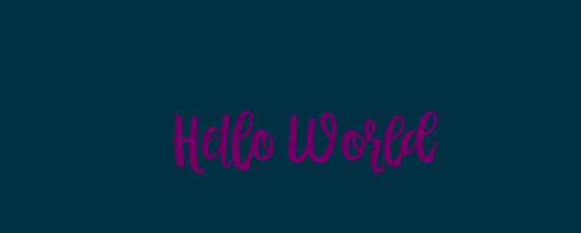

**SOLUTION**

If you want to give a modern touch to your website, you’ve got to know what your target audience needs; or else, you can fail miserably. Not having the perfect balance between the colors is one of the common website design problems that leads to ineffective web design. Make sure that the choice of colors does not affect the readability of the website. Furthermore, make sure that the use of colors is consistent throughout and in line with the overall theme. Don’t go all rainbows over the website. Decide a three to five color palette and stick to it. Customize and design your site according to your audience.

* Unclear Images. Ever heard the phrase “First impression is the last impression?” It’s actually true!
* When visitors open your site, the opening image is the first impression they will get. Use of low quality, abstract or irrelevant images is one of the common problems in web design that hinders communication with users.
* Good quality images certainly cost a lot of money but how much money will it cost if your website doesn’t have good quality images? Instead of counting every penny, think about how much money you will make through your site once you hire a professional photographer. As a matter of fact, a good photographer is worth every penny.

**SOLUTION**

Use images that are of good quality and have colors that correspond with the theme colors of the website; complementing the content and the message of the website.

* Unclear Objective.

Any visitor coming to the website should be able to tell instantly what the website is about. Users are likely not to visit the website again if they cannot understand the purpose of its existence.

**Solution:**

Evaluate whether the website is serving the purpose it is created for; whether all the CTAs are clear and each element in the design is helping the overall objective rather than competing with it.

* Lowering the Design Standards.

Too many decision-makers can ruin the project. Disagreements, taste comparisons, and negotiations lead to lowering the design standards. How can you get a quality outcome when the project committee discounts the expertise of professionals? It’s nearly impossible.



**Solution:**

Instead of hurting the quality standards, look for a proficient project team that expertise in digital design projects. Solution experts, whether they are UX researchers, branding specialists, or marketers, make sure that the decision-making team trusts their recommendations.

* Late Feedback Causes Disruption.

Key stakeholders have the power to steer the project into new directions. Bringing them too late in the project can lead to some serious consequences. They may reject designs or inquire premises which doubles the efforts, time, and cost, as you’ll have to start all over again.

**Solution:**

To fix this problem, explain to stakeholders how you can make the project successful and why decision-makers should be involved throughout the whole process. In case, the stakeholders aren’t ready to commit, ask them to nominate other decision-makers for the duration of the project.

* Not Responding to Questions & Poor Search.

Visitors often tend to leave a website that refuses to answer their questions. Your visitors will generally have questions like; how to get in touch with your company? What’s the price of a product or service? What’s your privacy or shipping policy? Where are you located? Your website visitors want you to answer their questions, so be prepared for it. How’s it done? Let’s have a look at the solution!



**Solution:**

A great onsite search engine can handle typos, plurals, hyphens, and keyword variations. Visitors, especially in e-commerce use search to find what they are looking for. If your site needs include search engine, prioritize the most relevant search results for each query.

* Slow Website & Server Response Time.

If a web page takes more than 4 seconds to load, it’s too slow. According to Google’s recent survey, 70% of the websites take seven seconds or longer to load. The survey also showed that the user is more likely to bounce if the site takes too much time to load. A site that takes forever to load is more likely to annoy the user away and what makes it even more complicated is that page speed can significantly impact your ranking. Yes, Google actually penalizes you for this. Some sites actually take forever to proceed. Another thing that can mess up your whole website is slow response time. Slow server time indicates that there is an underlying performance issue. If you have optimized your web pages for speed and your server response time is slow, this indicates that your website will be slow.

**Solution:**

Want to increase your website performance and speed? Choose a reliable web hosting provider. Upgrade your hosting package, as it allows you to get rid of the sluggish performance. Caching is also a helpful technique to improve a server’s response time. In order to reduce your server time, ensure that your server is fully optimized.

* Low-Quality Content & Grammar Issues.

No matter how stunning the image is, a poor text can ruin the whole charm of it and takes down the website with it too. A website littered with mistakes adds up to the bad impression and we’re sure you don’t want that to happen. Grammar can create a serious problem for your website. Although, this is one of the most common design problems, and most of the visitors won’t consider it much, but it does leave a bad impression on them. It erodes your credibility and can cost you a lot of money.

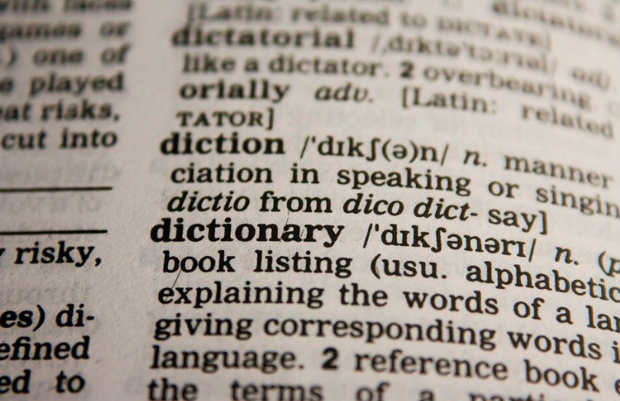

**Solution:**

Make sure you post good-quality content on your site. Get a professional writer for your site to generate revenue from your content, because if the content isn’t catchy enough to grab the attention of your visitor, what the whole point of it?

**RECOMMENDATION**

* First, if you are dealing with website design or graphics design you need to be updated in terms of software and technology because things are changing everyday so if you’re still out of date you may produce downgraded result.
* Second, on issue of advertisement it’s much better to make attractive adverts in order to attract more customer and also brand your name or company to the people or other company or organisation.
* Thirdly, if you’re dealing with online issues like websites or social media it’s better to invest a lot of time online in order to make sure that all responses toward your website or else from customers will be replied earlier.
* Fourth, quality service will attract people to follow your projects. Example in website the use of high quality medias, clear fonts and both desktop and mobile response may make your website grow fast
* Fifth, add contact information prominently. By examine your homepage objectively it may make your visitors to reach you. Example many small businesses add contact information in the header or footer of every page. At minimum include an email and phone number but if you receive customers at your location it’s better to add your address.